A1095-Mex-Mayan-Jaina Island-Goddess I-Ceramic Figurine-Campeche Phase III-1000-1200 CE

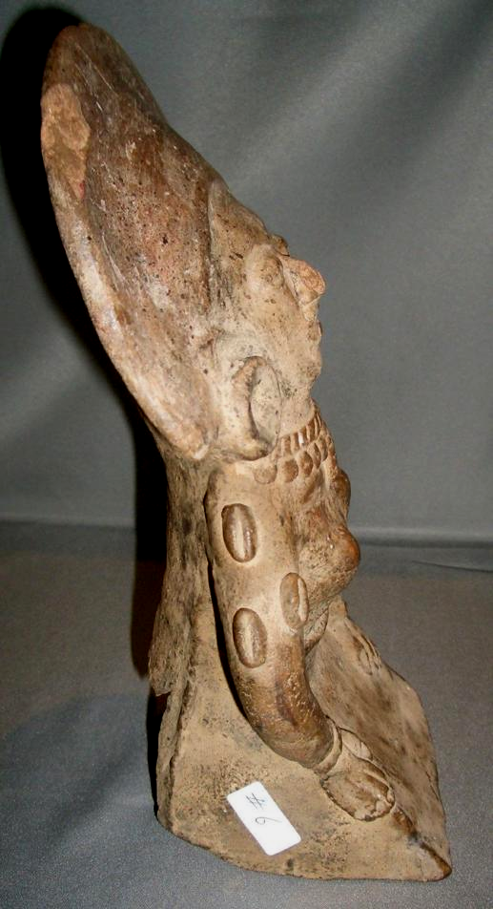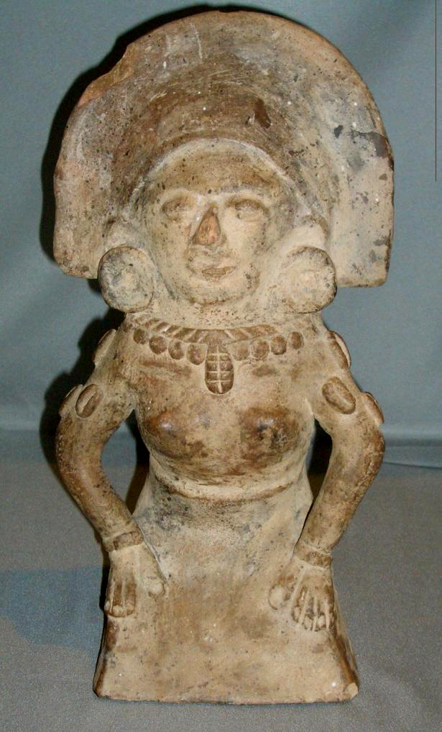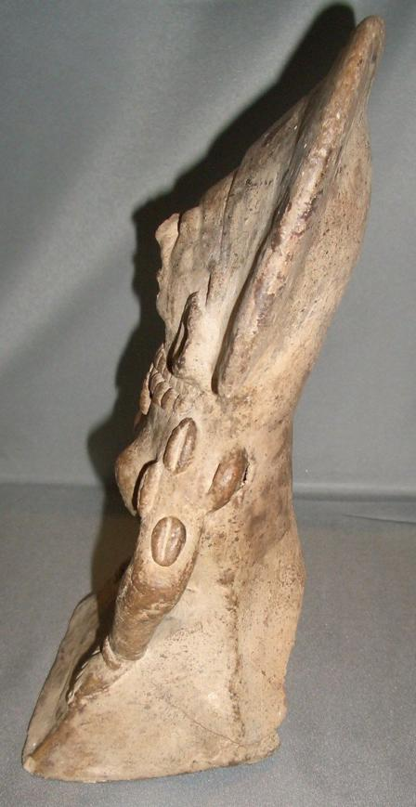

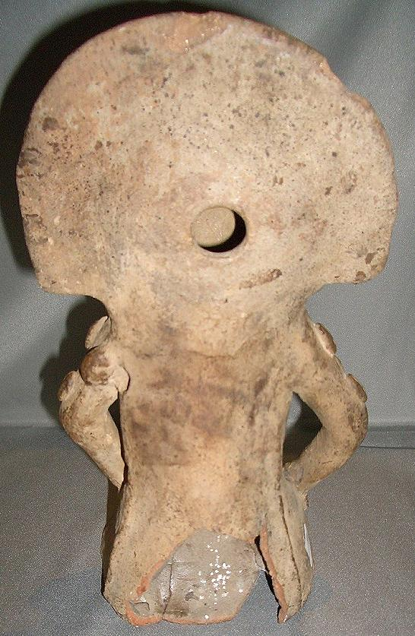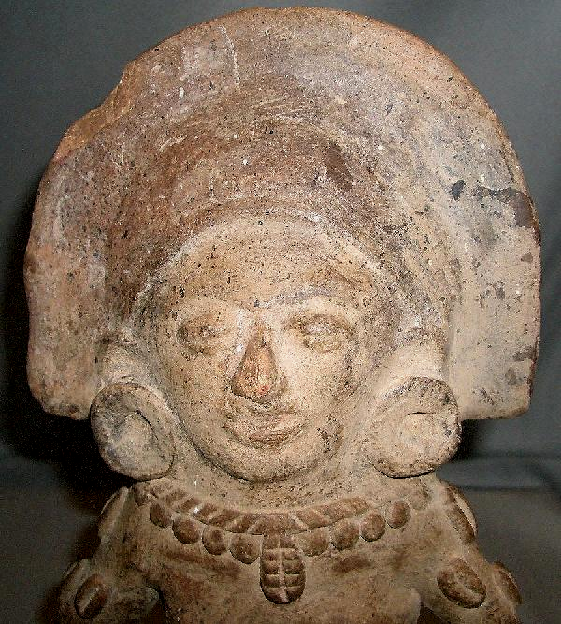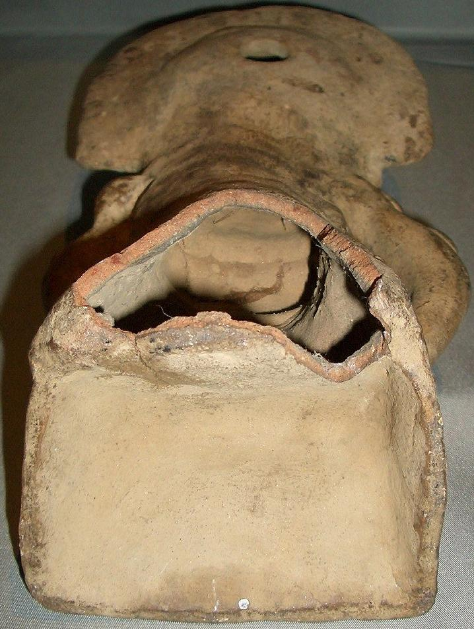

Figs 1-3. Mex-Mayan-Jaina Island-Goddess I-Ceramic Figurine-Campeche Phase III-1000-1200 CE

Case no.:

Accession Number: A 1095

Formal Label: Mex-Mayan-Jaina Island-Goddess I-Ceramic Figurine-Campeche Phase III-1000-1200 CE

**Display Description:**

This figurine of Goddess I (in the the Schellhas-Zimmermann-Taube designation) from Jaina Island dates to Campeche Phase III (1000-1200 CE) in which the figurine is reduced to a truncated form with legs omitted and the torso terminated in a flat–based pedestal (Corson 1977: 68). It may have been manufactured in Veracruz or the Usumacinta River drainage where Goddess I had been adopted in the Late or Terminal Classic Periods. Phase III emphasizes an easily recognized subject: an alluring, youthful maiden, attired with cowrie shells -- on her arms and suspended from her neck as a pendant –symbolizing the sexual functions of the nubile woman, eroticism, human procreation, and marriage (Taube 1992:145). She corresponds to the Aztec *Xōchiquetzal* ([*xōchitl*](https://en.wiktionary.org/wiki/xochitl)  “birth” and [*quetzalli*](https://en.wiktionary.org/wiki/quetzalli) “quetzal tail feather” aka Nahuatl *Ichpōchtli*, “maiden”), the goddess associated with fertility, beauty, female sexual power, and protectress of pregnancy, childbirth and young mothers.

Goddess I’s hieroglyph consists of a female head and a hair-like curl (prefixed or infixed). The curl is the sign of the earth (kab'[an]) or the moon (Landa's u-sign). The curl is the post-Classic infix for Classic glyphs for “woman” (ixik) (Stone and Zender 2011: 3). Goddess I’ hieroglyph is often preceded by the glyph for 'white' (sak) making Goddess I or “White Woman” of youth which contrasts with “Red Woman”, Goddess O or Ixchel, the aged patroness of midwifery.

**LC Classification:** F1435.1.J3

Date or Time Horizon: Campeche Phase III-1000-1200 CE

Geographical Area: Jaina Island

**Map, GPS coordinates:** 20.20750 -90.48389;40° 26' 46" N 79° 58' 56" W.

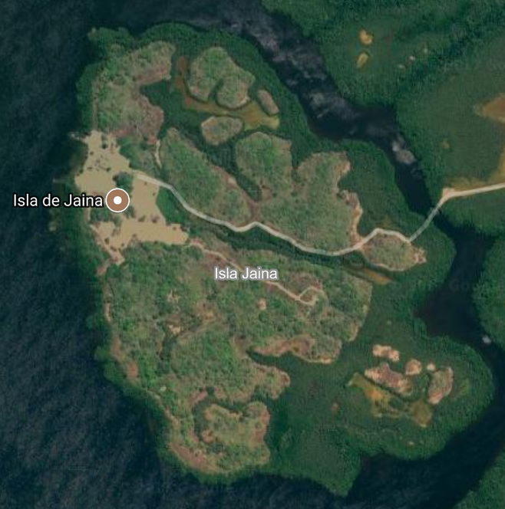 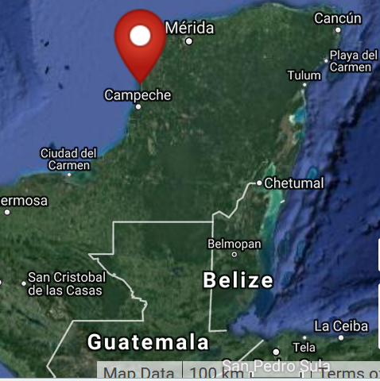

Cultural Affiliation: Jaina Phase I figurine

Media: clay

Dimensions: H 113.69 mm; 4.48 in

Weight: 154 gm; 5 3/8 oz.

Condition: original

Provenance: unknown.

**Discussion:**

Jaina Island, also known as "Temple in the Water" (Birmingham [Alabama] Museum of Art 2010: 85) is on the Yucatán Peninsula's limestone gulf coast and is separated from the mainland by a tidal inlet. It served as an élite Maya burial site where fine ceramic figurines were interred with the dead (Coe 1999: 143-144). Their place of manufacture was not necessarily on the island but could have been on the mainland extending along the coast of Campeche as this was the zone of marine trade and exchange.

Why was Jaina Island selected as the repository of so many mortuary figurines? The answer may lie in the *Popol Vuh* that proclaims all creation began in the sea: "Whatever there is that might be is simply not there; only the pooled water, only the calm sea, only it alone is pooled" (Tedlock 1985: 64). The Bearer and Begetter, who were in the water, created life. For the Maya both the beginning and the ending of humanity is in the waters to the west, and Jaina Island is one of the western-most islands off the coast of Campeche.

**References:**

[Birmingham [Alabama] Museum of Art](https://en.wikipedia.org/wiki/Birmingham_Museum_of_Art). 2010. [*Birmingham Museum of Art: guide to the collection*](http://artsbma.org/). [Birmingham, Ala]: Birmingham Museum of Art.

Coe, Michael D. 1999. The Maya. 6th ed. New York: Thames & Hudson.

Corson, Christopher. 1973. "Iconographic Survey of some principal figurine subjects from the mortuary complex at Jaina, Campeche,” University of California Berkeley, Archaeological Research Facility, *Contributions* 18: 51-75.

Corson, Christopher. 1975. *Maya Anthropomorphic Figurines from Jaina Island, Campeche*.  [Ballena Press studies in Mesoamerican art, archaeology and ethnohistory](http://www.worldcat.org/search?qt=hotseries&q=se%3A"Ballena+Press+studies+in+Mesoamerican+art%2C+archaeology+and+ethnohistory"), no. 1. Ramona, Calif.: Ballena Press.

Corson, Christopher. 1977 [1975]. “Stylistic evolution of Jaina figurines.” In Cordy-Collins, Alana and Jean Stern, *Pre-Columbian Art History: Selected Readings*. Palo Alto: Peek Publications, pp. 63-68. Previously published in the *Masterkey* (1975) 40:4.

Stone, Andrea, and M. Zender. 2011. *Reading Maya Art. A Hieroglyphic Guide to Ancient Maya Painting and Sculpture.* London: Thames and Hudson.

Tedlock, Dennis. 1985. *Popul Vuh. The Definitive Edition of the Mayan Book of the Dawn of Life and the Glories of Gods and Kings.* New York: Simon & Schuster.

Sold by [joeperadua](http://myworld.ebay.com/joeperadua) ( [3478](http://feedback.ebay.com/ws/eBayISAPI.dll?ViewFeedback&userid=joeperadua) )

+ Show additional actions

### Delivery package 1 of 1

Estimated delivery Tuesday, May 24, 2016 -Friday, May 27, 2016

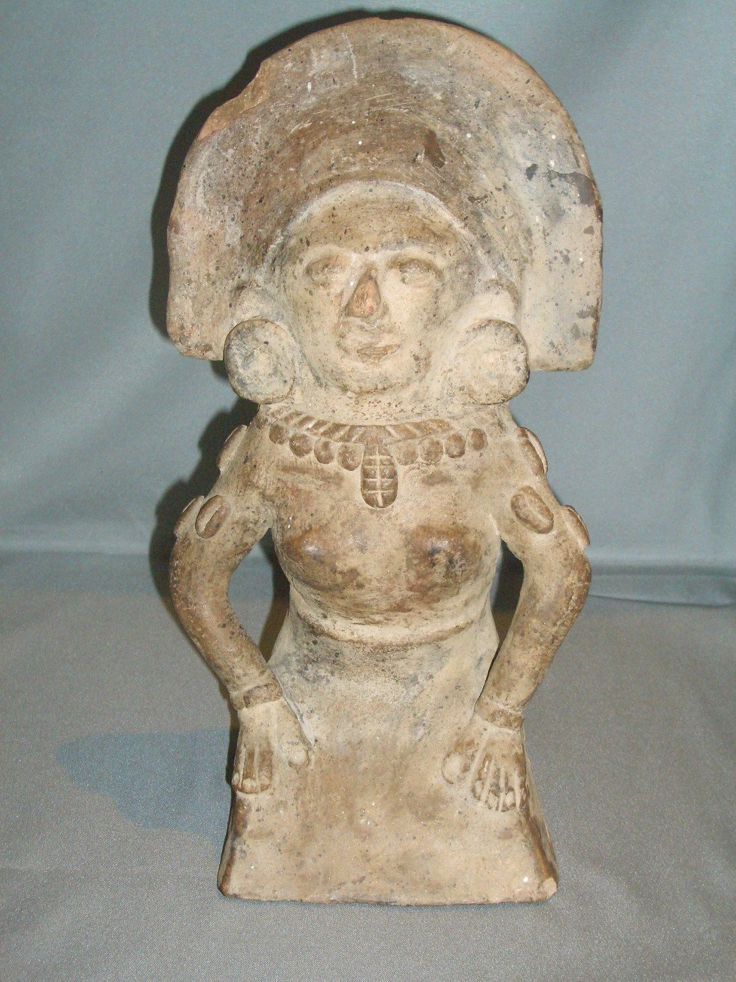

#### [Large Jaina Island Rattle Figure Mayan Mexican Genuine 600-900 A.D.](http://www.ebay.com/itm/371625917591)

|  |  |
| --- | --- |
| **Item price** | $349.99 |
| **Quantity** | 1 |
| **Item number** | 371625917591 |
| **Shipping service** | USPS Priority Mail |

Order placed on

Saturday, May 21, 2016

Payment method

PayPal

Payment date

Saturday, May 21, 2016